Collection

1. Collection Framework
Definition
Set of interfaces and classes used to store and manipulate data.

Hierarchy

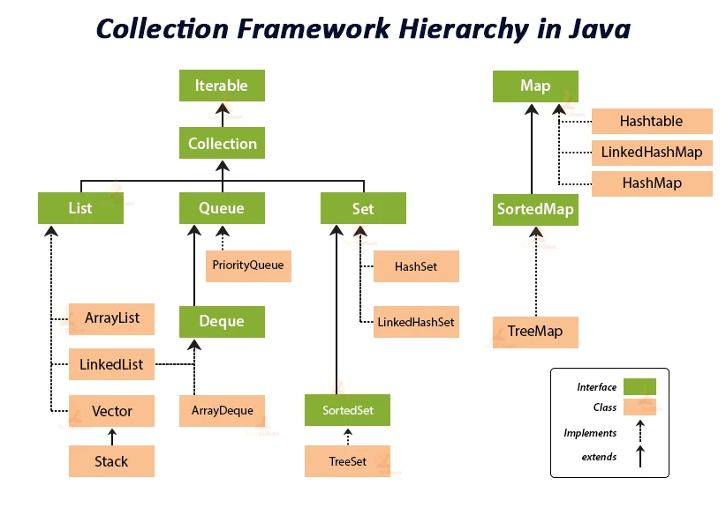

Iterable
Root interface, supports for-each loop.
iterator()

Collection
Parent interface of List, Set, and Queue.
add()
remove()
contains()
size()

Important
- Collection → Interface
- Root Interface → Iterable
- Map is not part of Collection
- Primitives not allowed

2. List
Yes, include all implementations:
List is an interface that defines rules such as insertion order, duplicates, null values, and index-based access. The actual data is stored by implementation classes like ArrayList, LinkedList, Vector, and Stack.
Or even shorter:
List is an interface that defines rules for storing data. ArrayList, LinkedList, Vector, and Stack implement these rules and store the actual data.

2.1 ArrayList

Definition
ArrayList is a class that implements the List interface using a dynamic array.

Interview One-Liner
ArrayList is a dynamic array implementation of List that maintains insertion order, allows unlimited duplicates and null values, supports index-based access, provides fast retrieval, and grows automatically by 50% when full.

2.2 LinkedList

Definition
LinkedList is a class that implements the List interface using a doubly linked list.

Interview One-Liner
LinkedList is a doubly linked list implementation of List that maintains insertion order, allows unlimited duplicates and null values, supports index-based access, stores data in nodes connected by previous and next references, and provides fast insertion and deletion without shifting elements.
How does LinkedList increase its size?
LinkedList does not resize like ArrayList or Vector. Every new element creates a new node and connects it using references, so there is no capacity or resize formula.

2.3 Vector

Definition
Vector is a class that implements the List interface using a dynamic array and is synchronized (thread-safe).

Interview One-Liner
Vector is a thread-safe dynamic array implementation of List that maintains insertion order, allows unlimited duplicates and null values, supports index-based access, and doubles its capacity when full using newCapacity = oldCapacity * 2.

2.4 Stack

Definition
Stack is a class that implements the List interface (through Vector) and follows the LIFO (Last In First Out) principle.

Interview One-Liner
Stack is a LIFO data structure that extends Vector, maintains insertion order, allows unlimited duplicates and null values, supports index-based access, and doubles its capacity when full.

3. Set

Definition
Set is an interface that defines rules for storing unique elements.

One-Liner
Set is an interface that does not allow duplicates and does not support index-based access. The actual data is stored by HashSet, LinkedHashSet, and TreeSet.

3.1 HashSet

Interview One-Liner
HashSet is a Hash Table based implementation of Set that stores unique elements, allows one null value, does not maintain order, uses hashCode() to find buckets and equals() to identify duplicates, and internally uses a HashMap where each element is stored as a key with a dummy value.
Red-Black Tree A self-balancing tree used to make searching faster.

3.2 LinkedHashSet

Definition
LinkedHashSet is a class that implements Set and stores unique elements while maintaining insertion order.

Interview One-Liner
LinkedHashSet is a Set implementation that maintains insertion order, does not allow duplicates, allows one null value, uses a Hash Table for uniqueness and a Doubly Linked List for maintaining insertion order.
.

3.3 TreeSet

Definition
TreeSet is a class that implements Set and stores unique elements in sorted order.

Interview One-Liner
TreeSet is a Red-Black Tree based implementation of Set that stores unique elements in sorted order, does not allow duplicates or null values, and uses compareTo() or Comparator for sorting and duplicate detection.

4. Queue

Definition
Queue is an interface that defines rules for storing elements in FIFO (First In First Out) order.

Interview One-Liner
Queue is an interface that follows the FIFO (First In First Out) principle, allows duplicates, generally does not allow null values, does not support index-based access, and is implemented by classes such as PriorityQueue and ArrayDeque.

4.1 PriorityQueue

Definition
PriorityQueue is a class that implements Queue and stores elements according to priority, not insertion order.

Interview One-Liner
PriorityQueue is a Heap-based implementation of Queue that stores elements according to priority, allows duplicates, does not allow null values, does not support index-based access, and by default follows Min Heap ordering where the smallest element has the highest priority.

4.2 ArrayDeque

Definition
ArrayDeque is a class that implements Deque (Double Ended Queue) and allows insertion/removal from both ends.

Interview One-Liner
ArrayDeque is a resizable circular array implementation of Deque that allows insertion and deletion from both ends, allows duplicates, does not allow null values, and is commonly used as a faster replacement for Stack and Queue.

5 Map

Definition
Map is an interface that stores data in Key-Value pairs.

Interview One-Liner
Map is an interface that stores data in key-value pairs, does not allow duplicate keys, allows duplicate values, and provides fast access to values using keys.

5.1 Hashtable

Definition
Hashtable is a class that implements Map and stores data as key-value pairs using a Hash Table. It is thread-safe (synchronized).

Interview One-Liner
Hashtable is a thread-safe Hash Table based implementation of Map that stores data as key-value pairs, does not allow duplicate keys, does not allow null keys or values, uses hashCode() and equals() on keys, and handles collisions using a Linked List that can be converted to a Red-Black Tree in Java 8+.
Yes, in simple interview terms:
Synchronized means only one thread can execute that synchronized method/block at a time.

Interview One-Liner
Synchronization ensures that only one thread can execute a synchronized operation on an object at a time, while other threads must wait for the lock to be released.

5.2 HashMap

Definition
HashMap is a class that implements Map and stores data as key-value pairs using a Hash Table.

Interview One-Liner
HashMap is a Hash Table based implementation of Map that stores data as key-value pairs, does not allow duplicate keys, allows one null key and multiple null values, uses hashCode() and equals() on keys, and handles collisions using a Linked List that can be converted to a Red-Black Tree in Java 8+.

5.3 LinkedHashMap

Definition
LinkedHashMap is a class that implements Map and stores key-value pairs while maintaining insertion order.

Interview One-Liner
LinkedHashMap is a Hash Table and Doubly Linked List based implementation of Map that maintains insertion order, does not allow duplicate keys, allows one null key and multiple null values, uses hashCode() and equals() on keys, and preserves insertion order using previous and next references.

5.4 TreeMap

Definition
TreeMap is a class that implements Map and stores key-value pairs in sorted order of keys.

Interview One-Liner
TreeMap is a Red-Black Tree based implementation of Map that stores key-value pairs in sorted order of keys, does not allow duplicate keys, does not allow null keys, allows null values, and uses compareTo() or Comparator for sorting and key comparison.

5.5 ConcurrentHashMap

Definition
ConcurrentHashMap is a thread-safe implementation of Map designed for high-performance concurrent access.

Interview One-Liner
ConcurrentHashMap is a thread-safe Hash Table based implementation of Map that allows concurrent access by multiple threads, does not allow null keys or values, uses hashCode() and equals() on keys, and provides better performance than Hashtable through fine-grained locking and concurrent updates.

Collection | Order Type
ArrayList | ✅ Insertion Order
LinkedList | ✅ Insertion Order
Vector | ✅ Insertion Order
Stack | ✅ LIFO (Last In First Out)
HashSet | ❌ No Order
LinkedHashSet | ✅ Insertion Order
TreeSet | ✅ Sorted Order
PriorityQueue | ✅ Priority Order
HashMap | ❌ No Order
LinkedHashMap | ✅ Insertion Order
TreeMap | ✅ Sorted Order (by Key)
Hashtable | ❌ No Order
ConcurrentHashMap | ❌ No Order

Memory Trick
Insertion Order
---------------
ArrayList
LinkedList
Vector
LinkedHashSet
LinkedHashMap

No Order
--------
HashSet
HashMap
Hashtable
ConcurrentHashMap

Sorted Order
------------
TreeSet
TreeMap

Priority Order
--------------
PriorityQueue

LIFO
----
Stack

You're moving to the next important collection topic.

Fail-Fast vs Fail-Safe

Fail-Fast
Throws ConcurrentModificationException if a collection is modified while iterating.

Interview One-Liner
Fail-Fast iterators throw ConcurrentModificationException when a collection is modified during iteration, whereas Fail-Safe iterators work on a copy of the collection and do not throw the exception.

Comparable

Definition
Comparable is used to define the natural sorting order of a class.

Interview One-Liner
Comparable is used to define the default (natural) sorting order of objects using the compareTo() method.

Comparator

Definition
Comparator is used to define custom sorting order.

Interview One-Liner
Comparator is used to define custom sorting logic outside the class using the compare(Object o1, Object o2)method.

Comparable uses compareTo() and defines natural sorting inside the class, whereas Comparator uses compare() and defines custom sorting outside the class.

